# OWNML MACHINE LEARNING CANVAS Designed for: Designed by: Date: Iteration: .

|  |  |  |  |  |
| --- | --- | --- | --- | --- |
| PREDICTION TASKWhat is the type of task? Which entity are predictions made on? What are the possible outcomes to predict? When are outcomes observed? • Tipo: Clasificación multiclase del nivel de obesidad (alternativa: clasificación binaria/regresión IMC según etiqueta disponible).• Entidad: Persona (registro individual).• Outcome: Nivel de obesidad (clases) o IMC estimado.• Observación del Outcome: Medición directa (altura/peso) o derivación (IMC→categoría). | DECISIONSHow are predictions turned into actionable recommendations or decisions for the end-user? (Mention parameters of the process / application for this.) • Activar recomendaciones personalizadas (nutrición, actividad, hidratación) y priorización de intervención; en empresa, inscripción dirigida a programas de bienestar; en investigación, selección de cohortes por riesgo. | VALUE PROPOSITIONWho is the end beneficiary, and what specific pain points are addressed? How will the ML solution integrate with their workflow, and through which user interfaces? • Para salud pública, bienestar corporativo y aseguradoras: reducir costos y anticipar riesgos identificando tempranamente niveles de obesidad; para banca/seguros, apoyar underwriting con señales de estilo de vida (cuando sea legal y con consentimiento informado). | DATA COLLECTIONHow is the initial set of entities and outcomes sourced (e.g., database extracts, API pulls, manual labeling)? What strategies are in place to update data continuously while controlling cost and maintaining freshness? • Para salud pública, bienestar corporativo y aseguradoras: reducir costos y anticipar riesgos identificando tempranamente niveles de obesidad; para banca/seguros, apoyar underwriting con señales de estilo de vida (cuando sea legal y con consentimiento informado). | DATA SOURCESWhere can we get data on entities and observed outcomes? (Mention internal and external database tables or API methods.) *•* Internas: hábitos (FAVC, FCVC, NCP, CAEC, SMOKE, CH2O, SCC, FAF, TUE, CALC, MTRANS), demografía (GENDER, AGE), antropometría (HEIGHT, WEIGHT).  • Externas: guías clínicas (clasificación por IMC), APIs de actividad física. |
| IMPACT SIMULATIONWhat are the cost/gain values for (in)correct decisions? Which data is used to simulate pre-deployment impact? What are the criteria for deployment? Are there fairness constraints? • Costos: intervenciones mal asignadas; Beneficios: reducción de riesgo cardiometabólico. Simular con históricos etiquetados, medir F1 macro, sensibilidad de clases de alto riesgo, y costo esperado. Criterios de despliegue: F1 macro ≥ 0.80 y sensibilidad ≥ 0.85 en clases críticas. Fairness: revisar sesgos por género/edad. | MAKING PREDICTIONSAre predictions made in batch or in real time? How frequently? How much time is available for this (including featurization and decisions)? Which computational resources are used? **•** Batch semanal para screening poblacional y tiempo real en captura de encuesta; SLA inferencia < 100 ms por registro; recursos: CPU/GPU ligera según volumen. |  | BUILDING MODELSHow many models are needed in production? When should they be updated? How much time is available for this (including featurization and analysis)? Which computation resources are used? • 1–2 modelos (principal + fallback). Actualización trimestral o por deriva (>2 p.p. caída en F1). Entrenamiento < 30 min; recursos: CPU. | FEATURESWhat representations are used for entities at prediction time? What aggregations or transformations are applied to raw data sources? • IMC=Peso/Altura^2; hábitos (FAVC, FCVC, NCP, CAEC, CH2O, SCC, FAF, TUE, CALC);  • Codificación categórica (one-hot/target encoding) y escalamiento numérico (Standard/Robust).  • Interacciones (edad×actividad) y umbrales clínicos (IMC≥30). |
|  | MONITORINGWhich metrics and KPIs are used to track the ML solution’s impact once deployed, both for end-users and for the business? How often should they be reviewed? | • Métricas online: F1 macro, sensibilidad alto riesgo, calibración (Brier/ECE), tasa de intervención efectiva.  • Deriva de datos (PSI) y desempeño; revisión quincenal (piloto) y mensual (producción). |  |  |

|  |  |  |
| --- | --- | --- |
|  | Version 1.2. Created by Louis Dorard, Ph.D. Licensed under a [Creative Commons Attribution-ShareAlike 4.0 International License](https://creativecommons.org/licenses/by-sa/4.0/). Please keep this mention and the link to [ownml.co](https://www.ownml.co/) when sharing. | [**OWNML.CO**](https://www.ownml.co/) |

# 

# [FREE] ONLINE COURSE

# Introduction to the Machine Learning Canvas

Get started with the MLC in this short course taught by its author.

[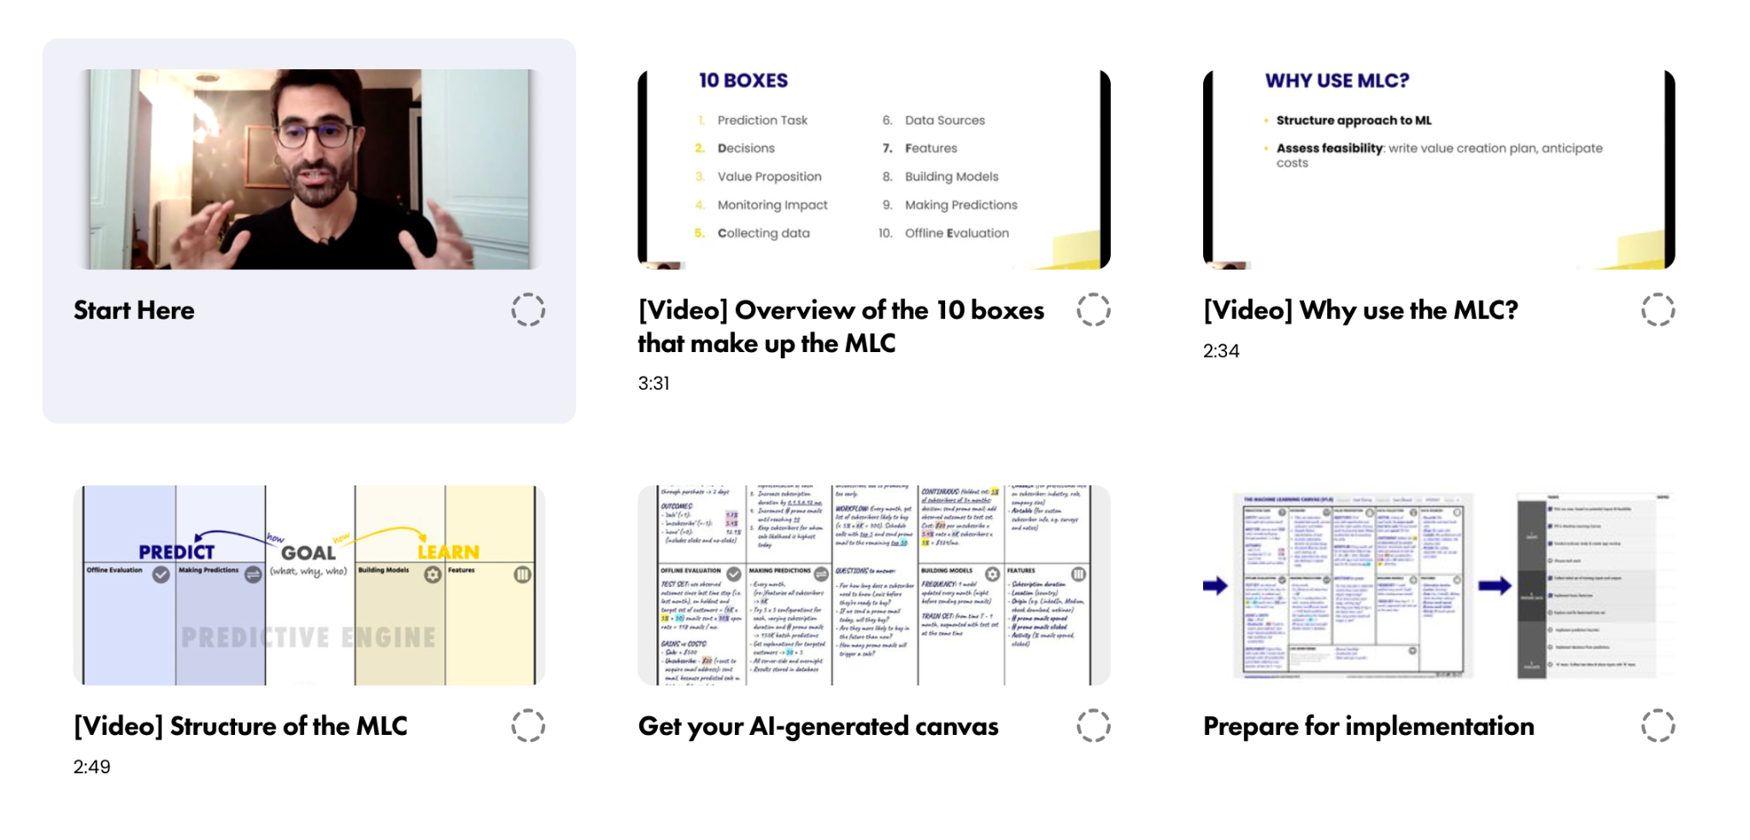](https://www.ownml.co/intro)

Start now at [**ownml.co/intro**](https://www.ownml.co/intro)